Outputs for mandatory hands-on for stage 1

Implementing the Singleton Pattern

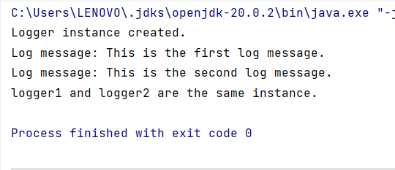

Implementing the Factory Method Pattern

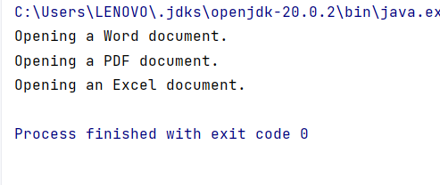

E-commerce Platform Search Function

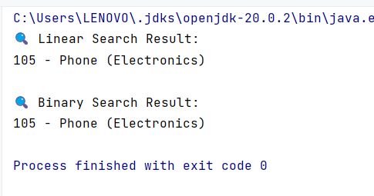

Financial Forecasting

